Leonard Cheshire

Gender Pay Gap Report – 2023
As a care organisation and charity in the UK, we strive to build a fairer, more inclusive society – one that recognises the positive contributions we all make, and where we are all proud to play our part.
In keeping with this, Leonard Cheshire is committed to building a workplace that is diverse and inclusive for our employees. Through various initiatives and strategies, we work hard to attract and retain employees, developing and offering rewarding careers to them regardless of disability, race, gender, sexual orientation, religion or belief, or age.
We are actively identifying and removing barriers and constraints that may impact negatively on our employees’ experience of Leonard Cheshire as an inclusive workplace.
This report covers statutory gender pay gap reporting.

Gender pay reporting
The Equality Act 2010 (Gender Pay Gap Information) Regulations 2017 requires us to carry out Gender Pay Reporting. This report is based on a snapshot from Leonard Cheshire on 5 April 2023. We have applied the standard methodologies required by the regulations.

Organisational context
At the assessment date, Leonard Cheshire was a charity supporting disabled people in the UK to fulfil their potential and live the lives they choose. Most of our workforce was employed in our services (93%). In line with norms in the social care and charity sectors, most of our staff are female (78%).

Headline gender pay gap
The gender pay gap is defined as the difference between the mean or median hourly rate of pay that male and female employees receive.
The median pay gap is the difference between the midpoints in the ranges of hourly earnings of men and women. The mean pay gap is the difference between average hourly earnings of men and women.
At Leonard Cheshire there is a median pay gap of -0.8%, compared to a UK median of 14.3% in favour of men. For the not-for-profit sector, the median pay gap is 17.3%. The Leonard Cheshire mean pay gap is 8.6%, compared to the UK mean pay gap of 13.2% in favour of men. The not-for-profit mean pay gap is 15.6%. Leonard Cheshire is favourably positioned against the not-for-profit sector and the broader market.
Leonard Cheshire does not operate a bonus scheme, so the figures reflected are for ordinary earnings only.
Market comparison
The following table reflects our median and mean pay gap figures, compared against gender pay gap ratios from the Office of National Statistics (ONS).
Organisation/source | Category | Median | Mean
Leonard Cheshire | All staff | -0.8% | 8.6%
ONS ASHE gender tables | Not-for-Profit fulltime employees | 13.2% | 13.7%
ONS ASHE gender tables | Not-for-Profit all employees | 17.3% | 15.6%
ONS ASHE gender tables | All fulltime staff | 7.7% | 10.7%
ONS ASHE gender tables | All staff | 14.3% | 13.2%
The data in the above table is also reflected in the graph below:
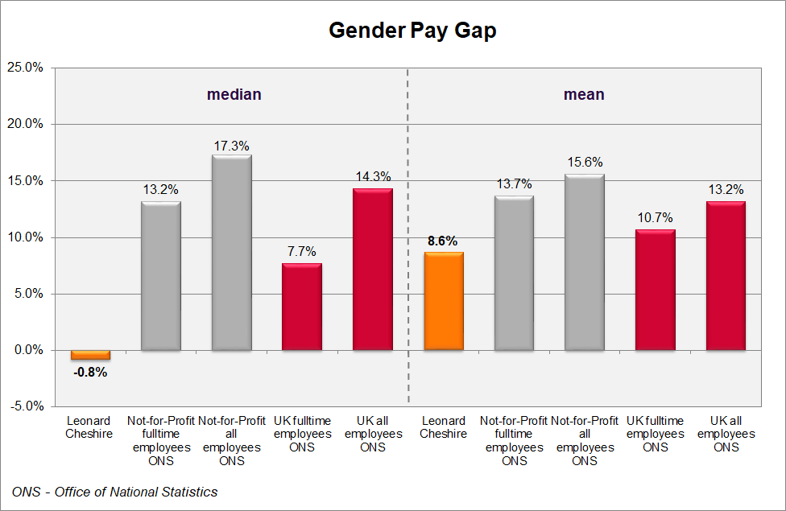
Comparison to previous years
The median ratio has decreased relative to 2022, while the gender pay gap as measured by the mean has increased. The increase relates to the inclusion of senior consultants associated with Leonard Cheshire’s turnaround strategy and to inclusion of consultants in in senior interim positions in the care operations focusing on service delivery improvement. Excluding consultants reduces the median pay gap from -0.8% to -1.1% and reduces the mean from 8.6% to 2.4%. Both these figures are lower than all preceding years’ figures.
The following diagram shows the same comparison graphically.
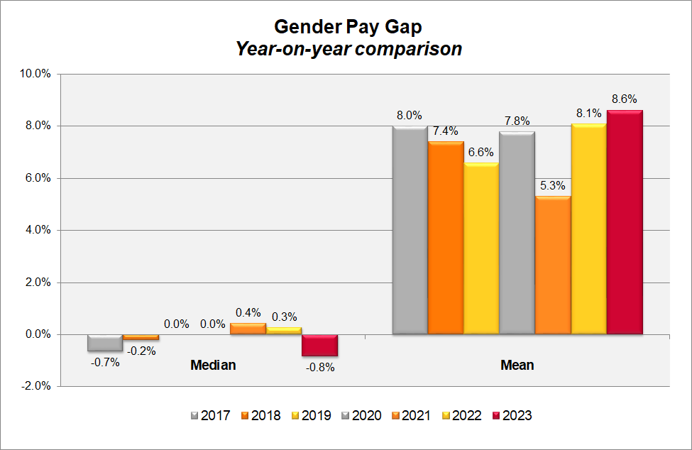

Proportion of male and female employees by quartile group
In line with the social care and charity sectors, Leonard Cheshire employs more women than men, with 78% of our employees being female, and 22% being male.
In the table below, we have divided our workforce into four equal groups ordered from lowest to highest paid. This shows that our female staff are distributed across each of these groups in a way that generally reflects the ratio of female and female staff across the whole organisation.
The proportion of male and female employees in Leonard Cheshire in each of the quartiles is as follows:
Quartile groups | Female | Male
Lower | 79% | 21%
Lower middle | 76% | 24%
Upper middle | 78% | 22%
Upper | 78% | 22%
All | 78% | 22%
The chart below shows the same quartile gender splits:
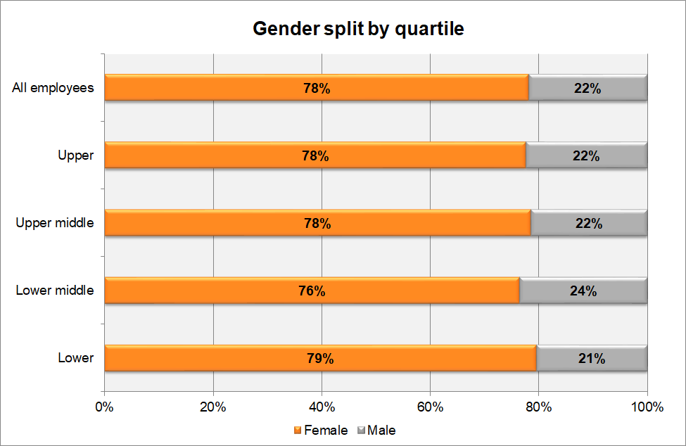

Findings from our gender pay gap analysis
Around 92% of our employees are hourly workers in our UK care operations so the median pay rate is strongly influenced by the size of this group.
Because the pay framework of these hourly paid employees is standardised by role, taking account of small regional variations for market factors, this has resulted in very consistent pay levels between male and female staff for this group, contributing to the generally neutral median gender pay gap for the organisation.
An integrated pay framework covers all salaried staff, based on the scale and level of complexity of the respective roles, so on an equivalent (“like for like”) basis, there is pay equity across these roles too.
Women are more strongly represented in lower-level roles, which include both hourly paid social care roles and more junior salaried roles. This brings down the average earnings for female employees relative to their male colleagues. While women are well-represented at the senior levels of the organisation making up 54% of these positions, this does not offset the impact of significantly higher proportions of women in smaller roles. The inclusion of higher than usual numbers of consultants associated with our turnaround strategy and service improvement, further contributes to the negative mean pay gap of 8.6% in favour of male employees. This figure has shown a negative shift since the previous report, for the reasons outlined above.

Responses to the gender pay gap analysis
Leonard Cheshire continues working to address our gender pay gap by:
- Continuing to ensure our reward frameworks enhance cross-organisational consistency and internal equity of pay.
- Continuing to encourage the culture of flexible working practices, to minimise career obstacles for working parents – responsibilities typically biased towards women.
- Building awareness of the structural gender bias in the social care and the charity sector and working consciously to counteract this.
- Working collaboratively with our Employee Inclusion Networks and the Staff Association, to increase awareness and further build our organisation as an inclusive workplace.
- Ongoing review of our recruitment process to ensure fairness in our process and parity in the offers being made to new starters.
- Ongoing review of our recruitment practices to seek to attract more women into typically male-dominated roles, with particular focus on Executive team roles.
- Seeking to invest in technical and leadership development, to assist in career progression.
- Review of our talent management and career development processes, with due consideration of career progression of women in the organisation.
While the structural aspects of the gendered nature of the social care and charity sector will continue to challenge us in narrowing our gender pay gap, we are committed to working towards this goal, while we continue to build our organisation as an inclusive, fair and empowering workplace.
Lynn Barbour
Head of Reward and Employee Engagement
Leonard Cheshire
February 2024

The data in this report is certified as accurate and is in line with statutory requirements.
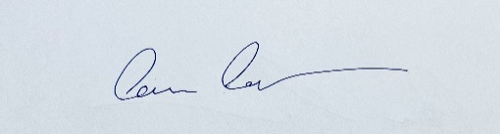
Jon Forde
Executive Director People
Leonard Cheshire

March 2024

All comparator figures are from Office of National Statistics (ONS) - Annual Survey of Hours and Earnings (ASHE) gender pay gap tables.
Heads of department, Directors, members of the Executive team

