Policy Title: Health & Safety Policy

Date last reviewed: 30th August 2019

Date due for review: 31st August 2020

1. Policy Statement 2
2. Policy Document Information - Purpose & Scope 3
3. Linked policies and procedural arrangements 5
4. Health & Safety Management 7
5. Roles & Responsibilities 12
6. How To Manage Risk 18
7. Information & Training 24

# Policy Statement

* 1. The health, safety and wellbeing of the people who use our services, our staff, volunteers and anyone who may be affected by our activities are the highest priority for Leonard Cheshire Disability. This means providing a safe and healthy environment. Further detailed objectives are recorded in the Health, Safety and Environment Management System.
  2. In addition to meeting the regulatory and legislative requirements relating to health, safety and environment as a minimum Leonard Cheshire Disability will use its management structure and systems to promote a positive health and safety culture.
  3. We expect all managers to play a role in achieving high standards of health and safety, with the recognition that health and safety issues are a prime management responsibility. Staff must be actively involved in the maintenance of health and safety standards at all levels of the organisation, and people who use our service and volunteers will be encouraged to be so.
  4. Health and safety training and information is provided to all employees and volunteers, as required, to improve knowledge and awareness of their responsibilities. Employees, people who use our services and volunteers have an essential role to play through reporting hazards and near misses, actively participating in health and safety action teams and cooperating with line managers in identifying risks and adopting the control measures that are laid down.
  5. While the overall responsibility for this Policy lies with the Trustees, the Chief Executive is responsible for its implementation and the People Director is the named director with responsibilities for health, safety and environment. The Trustees require health, safety & environment to be an agenda item at all regularly scheduled meetings of the Trustees Board, the Management Board and other such committees as the Trustees require to consider H&S.
  6. We are committed to continual improvement in Health and Safety performance and review of this policy and the H&S Management System on an annual basis, or as future health, safety developments and legislation, render appropriate.
  7. The Head of Health, Safety and Environment will be responsible for communicating this policy, and any changed to it to as appropriate to employees, people who use our services, volunteers and others working with us.

**On behalf of Leonard Cheshire Disability:**

Sally Davis Neil Heslop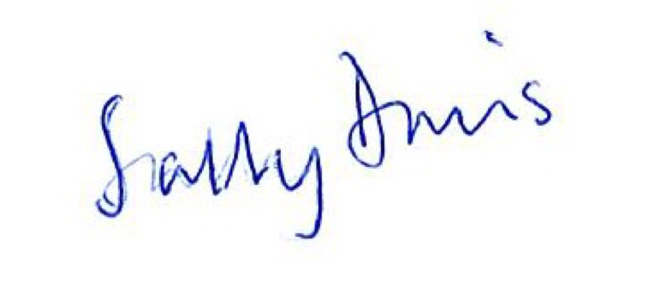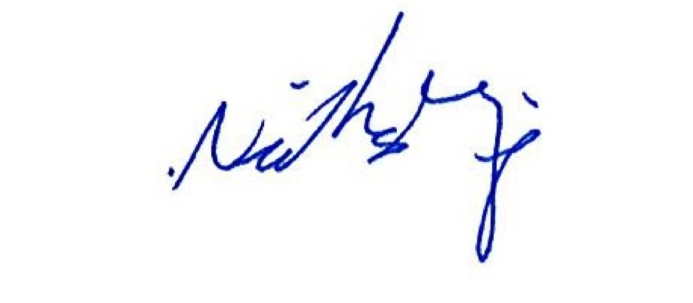

Chairman of Trustees Chief Executive

# Policy Document Information - Purpose & Scope

## Purpose

* + 1. The policy and arrangements in this document require all health and safety measures to be reasonable in relation to the assessment of the level and spread of risk.
    2. The main objectives of the Leonard Cheshire Health and Safety Policy is to ensure the safety and welfare of its employees, the people who use our services, volunteers, visitors, contractors and all others who may be affected by their activities.

## Scope

* + 1. This document identifies the agreed health and safety management arrangements and procedures for Leonard Cheshire. Specific operational risks relevant to our organisational activities and their necessary control measures are detailed within the individual Procedural Arrangements, which supplement and support this policy document.

## Policy basis

* + 1. The Management of Health and Safety at Work Regulations 1999, requires organisations with 5 or more employees to have a documented policy detailing the arrangements for the effective planning, organisation, control, monitoring and review of the preventive and protective measures.

## Policy document history

|  | Date | Author | Title | Changes |
| --- | --- | --- | --- | --- |
| Original Start Date | July 2014 | Jason McKenna | Head of Health Safety & Environment |  |
| First Review | August 2017 | Jason McKenna | Head of Health Safety & Environment |  |
| Second Review | August 2018 | Karl Monet | Health Safety & Environment Manager |  |
| Third Review | August 2019 | Graham Jarvis | Head of Health Safety & Environment | Removal of environmental references to reflect new stand alone environmental policy  Change of operations management titles to reflect current names  Change of asset management to property to reflect current title  Update of diagrams  Changes to training courses to reflect current training regime for managers  Merge of 8 sections into one single document  Reformatted to increase accessibility |

## Policy document communication strategy

* + 1. A safety alert will be issued advising all services and offices of the revised H&S Policy. In addition the Head of Health Safety & Environment and members of the HSE Team will undertake a series of visits to all Nations / Division, to attend Regional Director / Regional Manager Service Managers meetings to explain, why the changes have occurred, how this affected them and answer and questions or queries they may have. Service Managers will be required to cascade this information back to the staff at their services.
    2. Meetings will also be arranged at South Lambeth Road and the Shared Service Centre for non-operational staff. Non-operational home based staff will be given the option to attend either of the meetings at South Lambeth Road or the Shared Service Centre.

## References and further information

* + 1. Managing Health & Safety (HSG65) - Health & Safety Executive
    2. Leading Health & Safety (INDG417rev1) – Institute of Directors & Health & Safety Executive

# Linked policies and procedural arrangements

* 1. Leonard Cheshire’s approach to reducing its environmental impacts is now set out in our Environmental Policy.
  2. Further detail about how we manage the risks from fire, asbestos and water hygiene are set out in more detailed policies and supporting procedural arrangements.
  3. The following Health, Safety and Environmental Procedural Arrangements supplement and support this overarching policy document:
* Abrasive Wheels
* Alcohol at Work
* Asbestos
* Bathing, Showering and Washing
* Battery Safety
* Bedrails and Associated Equipment
* Charity Shops
* Children and Young Persons as Employees and Volunteers
* Compressed Gas Cylinders
* The Control of Legionella
* Control of Noise
* Display Screen Equipment
* Dissemination of Health and Safety Information
* Driving and Driver Safety
* Drugs at Work
* Electrical Safety and Portable Appliance Testing
* Emergency Planning
* Emergency Planning - Care at Home Services
* Events and Fetes
* Fire Safety
* Fire Safety Precautions for Tents and Marquees
* First Aid
* Flammable Substances
* Food Safety
* Foreign and Domestic Travel Arrangements
* General Safety and Good Housekeeping
* Grounds and Woodlands
* Hazardous Substances - COSHH
* Hazards and Defective Equipment Reporting
* Health and Safety Induction
* Health and Safety Signs
* Home-based Working
* Hostile and Adverse Environments
* Hydrotherapy Units and Swimming Pools
* Ladders & Scaffolds
* Latex Allergy
* Laundry Operations
* Lifts and Hoists
* Lighting
* Lone Working
* Manual Handling - People
* Manual Handling - Static Loads
* MDA Reporting and Dissemination
* Medical Equipment – Contaminated Devices
* Medical Equipment – Procurement & Use
* Medical Equipment – Single Use Devices
* Mobile Phones
* New and Expectant Mothers at Work
* Personal Protective Equipment
* Personal Safety
* Pest Control
* Pressure Systems
* Roof Work
* Safe Access and Egress
* Risk Taking by People Who Use Our Services
* Security of Personnel, Equipment and Property including CCTV Management
* Sharps and Needlestick Injuries
* Sluice Rooms
* Vehicle Safety
* Ventilation
* Visitors Safety and Security
* Window Cleaning
* Work Experience and Work Placement Students/Pupil
* Working in the Community
* Working at Height
* Working with Lead
* Work Space

# Health & Safety Management

## Introduction

* + 1. The Leonard Cheshire H&S Policy is based on the “Plan, Do, Check, Act” framework recommended by the Health and Safety Executive.
    2. The framework outlined below provides the context for the contents of this Health 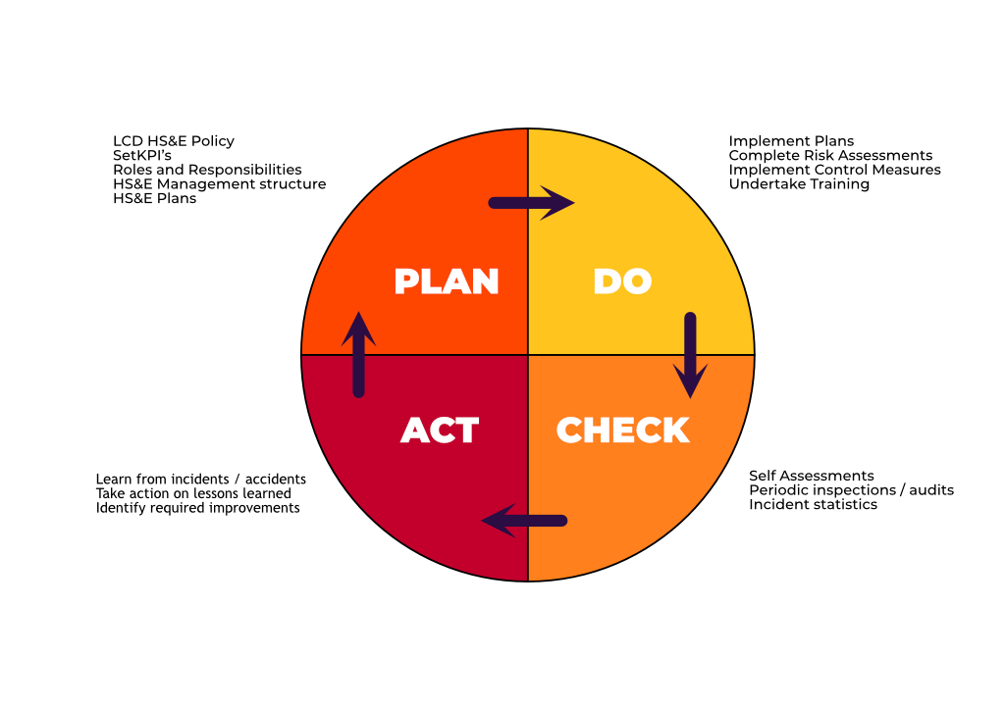Safety Policy.

## Leonard Cheshire Policy

* + 1. Leonard Cheshire is committed, so far as is reasonably practicable to ensuring the health, safety and welfare of its employees and others, including the people who use our services.
    2. Leonard Cheshire regards the promotion of Health, Safety & the Environment as a key element in providing a safe, healthy working environment and the maintenance of high standards will be a mutual objective for employees / managers at all levels.
    3. Leonard Cheshire’s H&S Policy takes into account the diverse nature of the organisation, and the legislative and regulatory requirements in running it.
    4. Whilst an annual review of fitness for purpose is enshrined within the procedures, the Policy is dynamic and will, in practice, be subject to far more frequent reviews as incidents occur, circumstances or legislative and regulatory requirements change.

## Organising

* + 1. Leonard Cheshire recognises that effective health and safety requires the co-operation of a number of parties to succeed, and that good communications throughout the organisation is vital.
    2. The policy is based on the Leonard Cheshire line management structure for clarity of purpose and seeks to integrate health, safety and the environment into the broader context of business risk management.
    3. The distinction between policy formation and operational delivery is achieved by having a single point within Leonard Cheshire to formulate H & S policy and guidance, and all parts of the organisation seeking to achieve compliance.

## Health Safety & Environment Team within the People Directorate

* + 1. The formulation of policy and associated guidance on health, safety and environmental matters in respect of legislative, regulatory or Leonard Cheshire organisational requirement is solely down to the HSE Team.
    2. Representations for changes in policy or guidance can be referred through line management channels, the health and safety committee structure or through consultation with the National Staff Association.

## People Director

* + 1. The postholder has the following responsibilities, and discharges them through The Head of Health Safety & Environment
    2. To ensure that Leonard Cheshire has a H&S Policy
    3. To confirm that it meets the needs of the organisation, and
    4. To ensure that it is regularly reviewed

## Head of Health Safety & Environment

* + 1. The Head of Health Safety & Environment has been designated as the overall “competent and responsible person” for policy and advice. The postholder has the following responsibilities;
    2. To maintain regular and effective liaison with all levels of Leonard Cheshire management and enforcement agencies (such as the Health & Safety Executive)
    3. To support the named posts within this policy so as to ensure they can be effective in their role
    4. To attend, in a professional support capacity, meetings of the Executive Team and charity trustees, and may attend other meetings as required
    5. To support the local Service Manager / Regional staff / Division or Nation staff / Head Office staff when dealing with any serious accident, dangerous occurrence or serious incident investigations
    6. To maintain the H&S Policy as required, reviewing it annually to ensure it remains relevant and effective
    7. To issue central advice on health, safety & environmental matters affecting Leonard Cheshire staff, people who use our services, visitors, contractors and others working within Leonard Cheshire accommodation
    8. To monitor accident returns and reports from Services and Internal Audit identifying trends and consulting on appropriate policy and guidance changes which may eliminate or mitigate those identified risks
    9. To specify, and monitor, the standards for health and safety training throughout Leonard Cheshire
    10. To deliver health, safety & environmental training as required by Leonard Cheshire, including coaching (1-1), to groups and presentations in support of the Policy objectives
    11. To maintain a good level of current professional knowledge through appropriate information and training

## Planning and Implementing

* + 1. At the November meeting of the Leonard Cheshire Management Board, a H&S Plan for the following financial year should be presented to the Management Board. Once agreed by them, this would come into force on the following 01 April. A communication to Head Office, Nations, Divisions, Regions and Services would take place immediately after approval in order to help them with their own plans.
    2. Normally in December for Nations / Divisions and February for Services / Regions, a draft H&S Plan based on their H&S Self-Assessment results should be formulated. This would be confirmed once the National H&S Plan was published, and would come into force on the following 01 April.
    3. Whilst this is a local tool, from time to time it may be necessary for either Leonard Cheshire or the Nation / Division to require services to include a generic topic in their H&S Action Plans. This would be announced through line management and H&S Committee channels, together with an explanation of just why it was required.
    4. At a local level, it is up to management to engage the local Health and Safety Link Person and National Staff Association Representatives and Staff and to involve them in both the planning and implementation parts of the process.

## Measuring Health And Safety Performance for Leonard Cheshire

* + 1. Defining clear objectives for health and safety performance can often be difficult, as the measures themselves are difficult to understand in the first place.
    2. For Leonard Cheshire, we have decided to go for something that can be quantified, so even part-compliance can be rated. Our system relies on evidence being available to back up the rating, and would be taken from an initial 10% sample at a site. The selection of those in the 10% sample is down to the auditor and chosen at random from a list.
    3. As health and safety compliance is a line management function, all reports are made through that route, as well as via the H&S committee structure.
    4. The topics detailed within the H&S Key Performance Indicators (KPI’s) require the Service Manager to be able to demonstrate a number of elements to demonstrate compliance with the topic. Advice on how to achieve compliance can be obtained from the HSE Team.

## Results

* + 1. The more honestly that the KPI’s are completed the better, as the results will provide the action points to be followed. They can also be used to raise matters through the line management structure when resource limits are exceeded at that level. Ultimately, matters may get raised at the Leonard Cheshire Management Board for consideration and direction / action.

## Reviewing Performance

* + 1. The H&S KPI Self-Assessment Form, also known as the Service Managers Monthly Report, should be completed every month, or quarter depending upon the service and subject to agreement with the HSE Team, and discussed at H&S Committees.
    2. Services should forward a copy to both their Regional Manager and HSE Team, allowing them to consider the results, and to help determine priorities for resources.

## Auditing

* + 1. Our auditing of H&S within Leonard Cheshire operates at three levels – firstly, at the service / location level; secondly, at Nation / Division / Regional level and lastly, at Organisational level.
    2. The audit is a sample of information and performance. The KPI topics provide the basis for the audit, and indicate what the information and performance criteria are.
    3. At local level, all services within Leonard Cheshire will be inspected by the HSE Team to ensure compliance with H&S procedures and standards and to ensure that the local self-assessments are being carried out in an appropriate and timely manner. The HSE Team inspections will take place on a rolling two-year programme, but the frequency and priority of these inspections will have regard to the risks involved and identified during the local self-assessments. This inspection programme does not prevent the HSE Team from inspecting a site outside of the planned programme if a need is identified, for example, if a serious incident has occurred.
    4. A full written report will be completed within 10 working days after the conclusion of the inspection, setting out any risks or non-compliance with procedures and standards identified, together with recommendations to remedy these, whether they are suggested improvement works or changes to operational procedures. This will follow the same format as the KPI Self-Assessment to enable quick and easy comparisons to be made.
    5. The completed report and summary of recommendations will then be sent to the Service Manager, Head of Property (where appropriate) and Regional Director / Regional Manager.
    6. The Service Manager then has 10 working days to put together an Action Plan to remedy any identified deficiencies from the report, and to submit it to the Regional Director / Regional Manager, HSE Team, and where appropriate Property. A further inspection may then take place to confirm that the deficiencies have been remedied.
    7. As and when required, an audit, for a specific topic or location, may be carried out at the request of Leonard Cheshire Management Board, Regional Director or Regional Manager and conducted by the HSE Team.
    8. At the Nation / Divisional level, this will be undertaken by the Head of Health Safety & Environment and will follow the same format as the audits of individual services but will involve Regional Managers, Regional Directors, Property and any other non operational departments as is necessary.
    9. The Head of Health Safety & Environment will also undertake the organisational level audit. The organisational level audit will involve a review of the management systems and process in place to ensure they meet legislative and industry requirements.
    10. The management systems and processes will also undergo an external independent review, to ensure that they are compliant.

# Roles & Responsibilities

## General Arrangements

* + 1. Leonard Cheshire Roles below have a responsibility to support the Chief Executive in ensuring the health, safety and welfare of the people who use its services, its employees and others, working in, on behalf of and / or visiting Leonard Cheshire.
    2. For locations where Leonard Cheshire is the 'Tenant’, responsibility for the fabric of the building and associated mains services usually lie with the Landlord. The responsibility for Leonard Cheshire clients, staff and visitors to Leonard Cheshire lies with Leonard Cheshire.

## The Chief Executive

* + 1. The Chief Executive of Leonard Cheshire has ultimate responsibility for the implementation of the Health and Safety policy within Leonard Cheshire. This includes the provision of the Leonard Cheshire policy, the circulation of guidance to staff and service managers and the auditing, monitoring of the implementation and application of the policy.
    2. To ensure health and safety standards are maintained and improved, the following have responsibility in their operational areas
    3. Leonard Cheshire Head Office Senior Management / Directors of Operations / Heads of Operations / Heads of Departments
    4. Head Office Senior Management, Directors of Operations, Heads of Operations & Heads of Departments have an overall general duty of care towards the people who use our services, staff, volunteers, visitors and contractors.
    5. They have overall responsibility for the effective management of health and safety in their operational domain following the Leonard Cheshire Health and Safety Policy.
    6. Head Office Senior Management, Directors of Operations& Heads of Operations should complete an Annual Health and Safety Plan, and an Annual Report detailing health and safety operations within their operational domain as required by the Leonard Cheshire Health and Safety Policy.

## Service Manager

* + 1. In particular, they have the following responsibilities
    2. To ensure the health, safety and welfare of all persons who use their service, employees, volunteers and visitors to their premises
    3. To ensure that a Personal Emergency Evacuation Plan is completed for any person who uses their service, member of staff, volunteer or contractor working regularly on site, who has advised Leonard Cheshire of their need for assistance during emergency evacuation of the premises
    4. To ensure that all accidents, injuries, and dangerous occurrences that arise are reported and recorded on the Leonard Cheshire Incident Report Form at the earliest opportunity and an investigation carried out in accordance with instructions
    5. To carry out an initial investigation following any such incident, and involving the HSE Team where appropriate
    6. To establish and maintain safe working premises and practices, and appropriate monitoring and control arrangements
    7. To carry out periodic site safety inspections / walkrounds
    8. To ensure that all employees are provided with adequate training, information and support in order to ensure that work is undertaken safely
    9. To order an immediate stop on any work being carried out by any contractor if they believe that the method of carrying out the work is unsafe or leads to increased risks for any other persons on the Leonard Cheshire premises. Property should then be contacted immediately for advice
    10. To immediately notify their Regional Manager, Regional Director, and the HSE Team should they receive any Enforcement Notice from a statutory body (eg Health and Safety Executive), or formal correspondence from them relating to a reported incident

## Health & Safety Link Person

* + 1. All sites and locations should have a member of staff responsible for local health, safety & environmental issues and for assisting the Service Manager to fulfil their health and safety responsibilities. They are required to:
    2. To advise service managers on aspects of health and safety appropriate to the workplace, undertaking safety inspections
    3. To work with the service manager to ensure that the necessary information, instruction and training is provided to visitors and contractors;
    4. To ensure the place of work is maintained in a condition that is safe, and without known risks to health.
    5. To take immediate and appropriate steps to investigate and rectify any risks to health, safety or the environment arising from work activities and in accordance with the Leonard Cheshire Incident Reporting procedural arrangement
    6. To ensure safe methods of working are employed
    7. To monitor compliance with the Health and Safety Policy regularly with systematic health and safety inspections of the workplace in accordance with Leonard Cheshire requirements
    8. To ensure the use, handling and storage of articles and substances is undertaken safely without known risks to health.

## Leonard Cheshire Staff & Volunteer Responsibilities

* + 1. Leonard Cheshire staff must recognise that they have an important part to play in the success of this policy, and;
    2. To take reasonable care for the health and safety of themselves, the people who use their service, their fellow employees and all other persons attending the service
    3. To co-operate with management in all aspects of health and safety
    4. To advise, if necessary, Leonard Cheshire of their need for assistance during emergency evacuation of the premises and to ensure that a Personal Escape Plan for them is completed with their line manager
    5. To comply with the instructions and procedures issued from time to time by management for safe working
    6. To only carrying out activities which they have been trained to undertake
    7. To make proper use of personal protective clothing and safety equipment provided
    8. To ensure that any health, safety & environmental hazard or any defect in safety procedures are promptly reported to their Line Manager / Service Manager
    9. To report promptly any incidents, which have led or might have led to injury or damage and to co-operate with any investigation, which may be undertaken with the object of preventing accidents or a recurrence of the incident.
    10. To attend all H & S Training and / or briefing sessions as requested by their line manager
    11. Full compliance with any smoking policy in force.

## People Who Use Our Services

* + 1. Everyone who uses our services must co-operate with whatever measures are put in place for their health, safety and welfare. This includes:-
    2. Complying with the site-specific health and safety instructions.
    3. Complying with evacuation procedures, and following the instructions of Leonard Cheshire staff in the event of an evacuation of the building.
    4. Not putting themselves or others at risk
    5. Should a visitor notice any potentially hazardous situation, they should alert Leonard Cheshire staff immediately.
    6. Full compliance with any smoking policy in force.

## Property Personnel

* + 1. Property Personnel support Service Managers, Regional Managers and Regional Directors to fulfil their health, safety & environmental obligations. In particular, they carry out the following duties:
    2. To act as a point of contact for Service Managers, Regional Managers & Regional Directors needing health and safety advice as applicable to estates matters and works
    3. To provide and maintain accommodation and amenities to standards that at least meet the minimum legal requirements
    4. To attend serious accidents, dangerous occurrences and serious incidents across the organisation as required
    5. To quality assure the work of contractors in terms of health and safety, and ensure correct contract compliance in all matters pertaining to health and safety.
    6. To work with Service Managers, Regional Managers & Regional Directors to ensure good standards of health and safety compliance from locally arranged contractors, to inspect safety method plans and to ensure that any permit to work systems are respected in detail
    7. To monitor the health and safety performance of contractors
    8. To immediately notify the relevant Service Manager, Regional Manager, Regional Director and the HSE Team should they receive any information about an Enforcement Notice from a statutory body (eg Health and Safety Executive), or formal correspondence from them relating to a reported incident being received from any location.

## Health, Safety & Environmental Advisors

* + 1. The HSE Advisors support the Service Managers, Regional Managers & Regional Directors to maintain good health, safety & environmental practice and legal compliance. The postholders have the following responsibilities:
    2. To provide advice, including best practice and legal compliance
    3. To assist with the implementation of all health, safety & environmental policies issued from the HSE Team
    4. To attend, in a professional support capacity, H&S committee meetings, and may attend other meetings as required
    5. To assist Property in monitoring the health and safety performance of managing agents and contractors
    6. To maintain regular contacts with the Regional Managers Service Managers, H&S Link Persons to spread examples of best practice throughout the organisation
    7. To carry out compliance checks (audits) against the standards in the H&S Policy, and report findings to the relevant Service Manager, Regional Manager, Regional Director and Property (where applicable)
    8. To support the Service Manager / Regional Manager / Regional Director when dealing with any serious accident, dangerous occurrence or serious incident investigations
    9. To monitor health and safety performance, including accident trends
    10. To audit that accident reports are submitted to the Health and Safety Executive (HSE) under the RIDDOR regulations where appropriate
    11. To collate health and safety data from their designated areas, analyse it and make recommendations regarding issues identified
    12. To correspond with enforcing agencies (such as the Health & Safety Executive) where appropriate
    13. To deliver health and safety training as required, including coaching (1-1), to groups and presentations in support of the H&S Policy objectives
    14. To maintain a good level of current professional knowledge through appropriate information and training

## Head Office & Shared Service Centre Heads of Departments

* + 1. Operational H&S risks are sometimes created as a result of instructions, policies or procedures issued from departments not directly involved in the operational activity. As a result they may not be aware of the H&S impact their instruction may have. To ensure that Head Office & Shared Services Departments do not issue instructions, policies or procedures that will create or increase H&S risks, Head Office Heads of Departments are required to;-
    2. Ensure the H&S impact of any new or revised instruction, policy or procedure is considered before the instruction etc is issued
    3. Consult with the relevant operational personnel and the HSE Team where such instruction etc may increase the H&S risk
    4. Amend the instruction etc as appropriate to ensure the H&S risk is eliminated or controlled, so far as is reasonably practicable

## The Responsibilities of Others Working In Leonard Cheshire Accommodation

## Contractor Responsibilities

* + 1. All Contractors working for Leonard Cheshire are required;-
    2. To comply with all relevant health, safety & environmental legislation, as far as they affected by their undertaking
    3. To abide by any health, safety & environmental rules imposed by or on behalf of Leonard Cheshire for contractors’ including those which are specific to local conditions
    4. To take reasonable care for the health and safety of their employees and any other person affected by their activities
    5. To carry out their activities in a safe manner and ensure that any equipment used is suitable and maintained in a safe condition
    6. To co-operate fully with the Leonard Cheshire representative
    7. To promptly report all accidents to the Service Manager or other locally nominated person
    8. To provide a Safe System of Work, if required, before beginning any work. In this event, no work must be carried out until the document has been completed and approved

## Visitor's Responsibilities (ie those on Leonard Cheshire premises but not at work)

* + 1. All visitors to Leonard Cheshire premises, whatever their reason, must co-operate with whatever measures are put in place for their health, safety and welfare. This includes:-
    2. Full compliance with any smoking policy in force.
    3. Complying with requirements on Notices clearly displayed in the reception area of all Leonard Cheshire premises detailing the site-specific health and safety instructions.
    4. Complying with requirements on Notices regarding evacuation procedures posted at all Leonard Cheshire locations. Visitors to the building should peruse these and follow the instructions of Leonard Cheshire staff in the event of an evacuation of the building.
    5. Remaining in those areas that are designated for their use when visiting a Leonard Cheshire service. They must not enter offices and other areas not open to the public except with prior permission.
    6. Ensuring that any children or young person(s) brought onto Leonard Cheshire property by Visitors are supervised for the duration of the visit
    7. Noting that they should not put themselves or others at risk whilst on Leonard Cheshire property. Should a visitor notice any potentially hazardous situation, they should alert Leonard Cheshire staff immediately.

# How To Manage Risk

* 1. Leonard Cheshire accepts that some of its operations will, unless properly assessed, mitigated and / or controlled, create a risk to employees, the people who use our services and others. It is therefore our policy to take all reasonably practicable measures to reduce those risks to an acceptable level, if it is not possible to eliminate them completely.
  2. The scope of risk assessments will cover all our activities, and where significant risks are identified after a task analysis, then a full formal risk assessment shall be completed. This will give full details, and list risk reduction, control strategies and monitoring measures.
  3. Staff, with relevant experience, who have been trained in Risk Assessment techniques will undertake the formal risk assessments and are thereby recognised by Leonard Cheshire as ‘Competent Risk Assessors’ in this regard.
  4. The HSE Team ensure that a common methodology is used, issues are dealt with in a consistent manner and will monitor the risk assessment process.
  5. The findings of risk assessments will be reported by the Competent Risk Assessors to line managers for action, and the H&S committees for information.
  6. Action required to remove or control risks will be implemented and monitored by service managers, or the reasons for non-implementation fully documented and reported to their Regional Manager & Regional Director.
  7. When the action requires budgetary approval above an individual’s limit, the action request shall be escalated to the Regional Manager, then Regional Director, to reach the relevant budget holder as appropriate.
  8. Regional Managers / Regional Directors will check that the implemented actions have removed / reduced the risks to an acceptable level, or that a suitable risk control strategy is in place. They will ensure these are monitored using an appropriate inspection system.
  9. Assessments will be reviewed according to the findings of the risk assessment, with higher risks being reviewed more frequently than lower risks; or when the work activity changes, whichever is sooner.
  10. More detailed information about specific arrangements can be found under the relevant Leonard Cheshire Procedural Arrangement e.g. Asbestos, Manual Handling, Display Screen Equipment, Personal Protective Equipment, Young Persons and relevant Operating Manuals.
  11. Leonard Cheshire will make every effort to only employ contractors who are deemed competent, in terms of their skills, knowledge, and expertise. This will also take account of their approach to, and management of, health, safety and environmental safety.
  12. Where other employers have employees working on Leonard Cheshire premises, or Leonard Cheshire-controlled premises, an agreement between the parties shall include an exchange of information relating to safety risks that each potentially pose to the other, and these arrangements will be regularly reviewed to monitor their effectiveness.

## Risk Assessment MethodologyA diagram showing how we manage risks. We identify the hazards from our activities, identify who is exposed, evaluate the risk and then decide if the control measures are adequate. If they are not, we implement effective control measures until they are, and in all cases we document the findings of our decisions.

## Template Task-Based Risk Assessments

* + 1. Where Leonard Cheshire controls a number of similar workplaces containing similar activities, then ‘template’ risk assessments reflecting the core hazards and risks will be produced.
    2. Such assessments can then be applied by service managers, and trained risk assessors, throughout Leonard Cheshire at their particular location or service, but only if they satisfy themselves that the local conditions are covered by those detailed within the template assessment. Where the local conditions differ to those detailed within the template assessment, it should be adapted to suite the local conditions to ensure that the risk assessment is relevant for the location it is being carried out for.

## Risk Management

* + 1. Safety Risk Management is all about knowing what could cause Leonard Cheshire to suffer loss in the widest sense eg injuries to people (people who use our services, staff and other persons), damage to property, reputation, or financial loss, and managing them effectively.
    2. In these times of finite resources, it also provides guidance on what you should concentrate on first from what may be a long list.
    3. It comprises three of parts:

|  |  |
| --- | --- |
| Risk Assessment | Working out just what can happen and how bad it would be were it to do so  Done on the basis of ‘Reasonable Foreseeability’, that is what we can expect, but rules out the outlandish  The control measures in our risk assessments are the start of our Risk Reduction procedures |
| Risk Reduction | doing something to mitigate the risk to the lowest level that is reasonably practicable  Done on the basis of ‘Reasonable Practicability’, that is a ‘Cost v Benefit’ judgement in the first instance |
| Risk Monitoring | making sure that you know how well you are doing as you go along, and undertaking corrective actions as necessary  Done on the basis of ‘Regular checks against the risk assessments and actual events’  Use of a Risk Register listing all the Risk Assessment Outcomes |

## Risk Assessment

* + 1. Legally, we have to assess all the risks that our business faces and to formally record the results of anything that we consider ‘significant’. That simple idea presents a problem however as we are often asked to confirm that we actually looked at something we considered not significant.
    2. The method that we use allows us to easily answer either of those points and is based on what can happen rather than a system based on fixtures and fittings. It comprises two parts - a first quick listing of what can occur, and an estimate of the risk involved. Where the results fall into our definition of ‘significant’, (High or Medium Risk), a much more detailed analysis is required. This process is referred to as a task analysis.
    3. When starting out doing risk assessments it is probably easier to have a longer list and trim it / combine things later, rather than possibly miss something out. The Risk Assessment guidance document will help you understand about risk assessment, and what is meant by some of the terms.

## Risk Reduction

* + 1. Once risks have been analysed and assessed, decisions about workplace precautions should be made on the basis of the hierarchy of risk control measures.
    2. Priority should always be given to the hazards that pose the highest risks and their elimination is the preferred first option.
    3. If that is not reasonably practicable, then the adoption of ‘engineering’ solutions, followed by recognised good practice will generally be enough to ensure adequate risk control.
    4. Authoritative sources of good practice include Approved Codes of Practice, Health & Safety Executive guidance and Leonard Cheshire Standards.

|  |  |  |
| --- | --- | --- |
| 20-25 | HIGH RISK and INTOLERABLE LEVEL | Action must be taken to reduce from this level as a Priority. No opportunity for delay. Could have serious repercussions if allowed to remain unmanaged. Lack of funding would not be acceptable as a reason for continuing with this. Cannot continue doing this if resources are unavailable. Cost v Benefit DOES NOT apply in this situation. |
| 15-16 | HIGH RISK | Action must be taken to reduce from this level as a Priority. Little opportunity for delay. Could have serious repercussions if allowed to remain unmanaged. Lack of funding would not be acceptable as a reason for continuing with this, unless an interim reduction in risk was achieved before full resources became available later. Should not continue doing this if resources are unavailable, or if the risk cannot be reduced. |
| 5-12 | MEDIUM RISK | Action must be taken to reduce from this level to as Low as is Reasonably Practicable. Sooner rather than later, but not necessarily immediately. Could have moderate repercussions if allowed to remain unmanaged. Lack of funding may be acceptable as a reason for delaying this, so long as an interim reduction in risk was achieved before full resources become available later. |
| 1-4 | LOW RISK | Risks in this category will be monitored regularly to ensure that the risk has not increased but action should not be expected until all higher risks have been dealt with. Needs to be managed, and funding may well be an issue, as higher risks naturally take their share first. Should not be forgotten just because it is Low Risk. |

## Risk Monitoring

* + 1. There are a number of triggers for risk ratings to be reviewed, but all come from looking at the organisation.
    2. Should there be any operation or task changes, then consideration must be given to undertaking a local risk assessment review.
    3. However, the most common trigger is where an incident, which includes near misses, has occurred. The fact that it has, means that the risk assessment, designed to inform, alert and protect, might have failed in some way. It therefore needs to be rechecked as part of the incident investigation process. In addition, following any serious incident the Service Manager must conduct a review of the relevant risk assessments to see whether they are still satisfactory, including looking at any procedural concerns. Any concerns should be immediately escalated to the HSE Team.

## Risk Register

* + 1. This is simply a list of ALL your Health, Safety & Environmental Risk Assessments in descending order, starting with any ‘25s’ and ending with the ‘1s’. It is usually possible to decide which of two ‘equal values’ is the higher risk for example, and so the list should be rated top to bottom. The columns in the Risk Register should be as this example

## Top ‘X’ Risk Reporting for Health, Safety & the Environment

* + 1. Modern safety is all about risk management, and as part of that, demands that those accountable and responsible know what the extent of their liabilities are, so that they may prioritise resources to deal with them.
    2. There is no reason why health and safety should develop this style of risk reporting in isolation, but rather it should form part of the wider Business Risk Management programme. For the sake of explanation of the process involved though, that option has been excluded from these notes. (Experience shows, from other organisations, that health and safety risks will only form a very small part of the overall risk picture, despite the issues being quite evocative and emotive.)
    3. At the lowest level of Leonard Cheshire, each location should, after completing their risk assessments, know what their top risks are. For practical purposes, these should normally be the ones rated as High Risk, scoring 15 - 25 on the risk matrix. The actual number of High Risks will depend on local circumstances. They report these to the next upwards tier in the chain = the Regional Manager who report upwards to the Regional Director.
    4. By the very nature of the risk assessments, the top risks may be expected to be similar, and so when these reach that tier, it is possible to collate them reducing the overall number. Some may be able to be dealt with immediately because of the higher authority (access to budgets; personal spending authority etc).
    5. Others will be beyond that scope and thus a smaller number of risks are reported upward until the Management Board is reached. It should be noted that even with risks rated as High Risk, the decision to resolve the matter is one of reasonable practicability. The Management Board has joint and several liability, and it is their choice to resolve the matter immediately, or to consider it at a later stage.
    6. As far as enforcement is concerned, so long as the matter has been properly reported upwards (and documented as such), then responsibility moves upwards at the same time. Ultimately, responsibility gets to the Management Board.

# Information & Training

## Information

* + 1. Leonard Cheshire is committed to ensure that all appropriate information regarding health, safety, welfare and the environment is provided to all employees, staff association representatives and other persons concerned. In addition, all statutory notices will be displayed as appropriate.

## Training

* + 1. The training offered seeks to ensure that Leonard Cheshire is capable of complying with relevant legislation, and provide staff with the suitable and sufficient level of knowledge and understanding of the risk management process in order for them to carry out their role without exposing themselves or others to unnecessary levels of risk of injury.
    2. The list of courses and their target audiences are:

## All new starters (INCLUDING temporary and casual employees)

* + 1. Will complete a local Safety Induction. This covers key fire, health and safety, and environmental information, and forms the basis for subsequent health, safety & environmental training.

## All Directors (Management Board, Directors of Operations & Head Office Senior Management Directors) & Head of Operations and Head Office Departments / Groups

* + 1. Will complete a half day strategic level training workshop, valid for three years. This covers both Leonard Cheshire information as well as an external accrediting organisation’s Safety for Senior Executives level course content. (Heads of Operations should also attend Risk Management Training for Service Managers so that they are aware of what is expected of their Service Managers).

| SAFETY FOR SENIOR EXECUTIVES (0.5 day) |  |
| --- | --- |
| Aims | To provide Directors within Leonard Cheshire with an understanding of their health, safety & environmental role and how this should influence their strategic thinking and holistic risk management practices |
| Learning Objectives | To give Senior Executives in larger organisations a better practical understanding of:  Responsibilities, accountabilities and liabilities in modern safety management  The importance of Core Values  The function and practicalities of modern Safety Management Systems  How safety systems link with business/operational systems  Modern legal requirements & responsibilities for safety as they apply to the organisation’s activities and particularly to Directors  How to discharge strategic safety responsibilities effectively  How to avoid some of the pitfalls of poor safety management  The need for continual improvement and methods for periodic reporting on/monitoring of safety performance |
| Outline Programme | The Legal, Moral and Business Case for Safety Management  Caution - Moving Goalposts; The Balancing Act  Core Values & Safety Management Systems  The Need for Ongoing Assurance  Responsibilities of/Implications for Directors and Senior  Management Teams  Risk Management as the Cornerstone for European Safety Management  Legal Framework  Causes of Accidents/Ill-Health  Definitions of Risk Management - & Implications  Operational Definition of Risk  Risk Assessment  Management of the Assessment process  Using ‘Generic‘ & ‘Dynamic Risk’ systems  Risk Control Principles  Records & Future-proofing - Audit Trails  Risk Monitoring  Organising for Safety Management  Attitudes to Risk  Essential Components of Safety Management  More on the role & content of Safety ‘Systems’  Competency & the role of the external accrediting body  Risk Management in the Real World  Making it happen – SMART Accountabilities  The ‘Top X’ Principle  Safety as a part of Business Risk Management  Where do we go from here - ACTION PLANNING |

## Service Managers, Regional Managers, Regional Directors & Health & Safety Link Persons

* + 1. Will complete a three-day technical level training course, valid for three years, covering all aspects of health, safety & the environment for service managers based on risk management principles. This covers both Leonard Cheshire information as well as an external accrediting organisation’s Managing the Risk Assessment and Risk Control Processes course content. An assessment concludes the course and successful delegates will be awarded an externally accredited certificate.

| EVERY DAY SAFETY MANAGEMENT (ESM) |  |
| --- | --- |
| Aims | Delegates will understand everyday safety practices and learn practical safety skills, tools and techniques to play an effective role in the promotion and maintenance of a positive safety culture within their area of influence |
| Learning Objectives | Understand the practical implications of health and safety law as it applies to their organisation  Understand and supervise safe systems of work that have resulted from the risk assessment process  Play an active role in incident reporting and investigation  Be able to support colleagues in promoting safe behaviour within their organisation |
| Outline Programme | What does ‘safe’ look like: Safety systems, core values, legal principles  Risk Assessment  What does leading safety look like: Safe behaviour, safe systems of work, and the three step process  Investigating incidents and a way forward: The causes of incidents & Investigating incidents  Review of the programme and action planning |

## Property Team

* + 1. Will complete relevant training as is necessary for their role. At present this will include advanced asbestos training and fire safety training in accordance with our forthcoming asbestos and fire safety policies.

## The HSE Team

* + 1. Will complete such training as is necessary to achieve, and maintain, membership of a recognised professional body. Such training will normally include a health and safety qualification at the Qualifications and Curriculum Authority Level 6 standard, together with other specialist courses that relates directly to their activities within Leonard Cheshire eg General Risk Assessor status.

## Task Related H&S Training

* + 1. All task related H&S Training, such as Manual Handling, Infection Control, Food Safety, etc. will be provided to all staff who undertake those specific tasks. A training needs analysis guide will be produced for all services to use as an aid to identify which individuals undertake such tasks that require specific task related training.