Leonard Cheshire

Gender Pay Gap Report – 2021

As a charity in the UK and internationally, we strive to build a fairer, more inclusive society – one that recognises the positive contributions we all make, and where we are all proud to play our part.
In keeping with this, Leonard Cheshire is committed to building a workplace that is diverse and inclusive for our employees. Through various initiatives and strategies, we work hard to attract, develop and offer rewarding careers to employees regardless of disability, race, gender, sexual orientation, religion or age.
We are actively identifying and removing barriers and constraints that may impact negatively on our employees’ experience of Leonard Cheshire as an inclusive workplace.

This report covers statutory gender pay gap reporting.

Gender pay reporting
The Equality Act 2010 (Gender Pay Gap Information) Regulations 2017 requires us to carry out Gender Pay Reporting. This report is based on a snapshot from Leonard Cheshire on 5 April 2021. We have applied the standard methodologies required by the regulations.

Organisational context
Leonard Cheshire is a charity supporting disabled people in the UK and around the world to fulfil their potential and live the lives they choose. Most of our UK workforce is employed in our UK services (89%). In line with norms in the social care sector, most of our staff are female (78%). A higher proportion of female workers is also common in the charity sector.

Headline gender pay gap
The gender pay gap is defined as the difference between the mean or median hourly rate of pay that male and female employees receive.

The median pay gap is the difference between the midpoints in the ranges of hourly earnings of men and women. The mean pay gap is the difference between average hourly earnings of men and women.

At Leonard Cheshire there is a median pay gap of 0.4%, compared to a UK median of 15.4% in favour of men. For the not-for-profit sector, the median pay gap is 20.8%. The Leonard Cheshire mean pay gap is 5.3%, compared to the UK mean pay gap of 14.9% in favour of men. The not-for-profit mean pay gap is 18.0%. Leonard Cheshire is favourably positioned against the not-for-profit sector and the broader market.
Leonard Cheshire does not operate a bonus scheme, so the figures reflected are for ordinary earnings only.

The following table reflects our median and mean pay gap figures, compared against gender pay gap ratios from the Office of National Statistics (ONS).
Organisation/source | Category | Median | Mean
Leonard Cheshire | All staff | 0.4% | 5.3%
ONS ASHE gender tables | Not-for-Profit fulltime employees | 15.8% | 15.7%
ONS ASHE gender tables | Not-for-Profit all employees | 20.8% | 18.0%
ONS ASHE gender tables | All fulltime staff | 7.9% | 11.9%
ONS ASHE gender tables | All staff | 15.4% | 14.9%

The data in the above table is also reflected in the graph below:
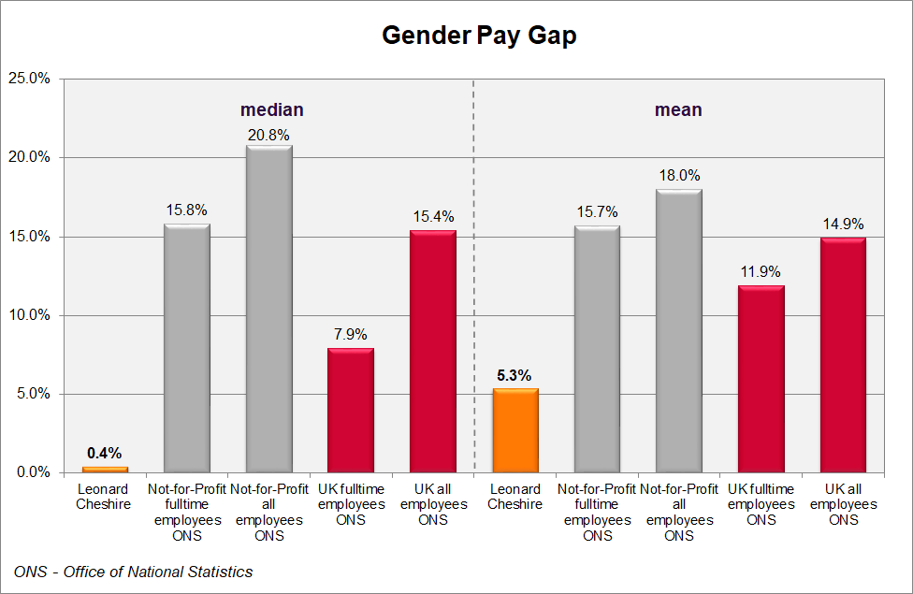

Comparison to previous years
 | 2021 | Diff to 2020 | 2020 | Diff to 2019 | 2019 | Diff to 2018 | 2018 | Diff to 2017 | 2017
Median | 0.4% | 0.4% | 0.0% | 0.0% | 0.0% | 0.2% | -0.2% | 0.4% | -0.7%
Mean | 5.3% | -2.5% | 7.8% | 1.2% | 6.6% | -0.8% | 7.4% | -0.6% | 8.0%

The median ratio has increased marginally relative to 2020, while the gender pay gap as measured by the mean has decreased materially.

The following diagram illustrates the same comparison graphically.
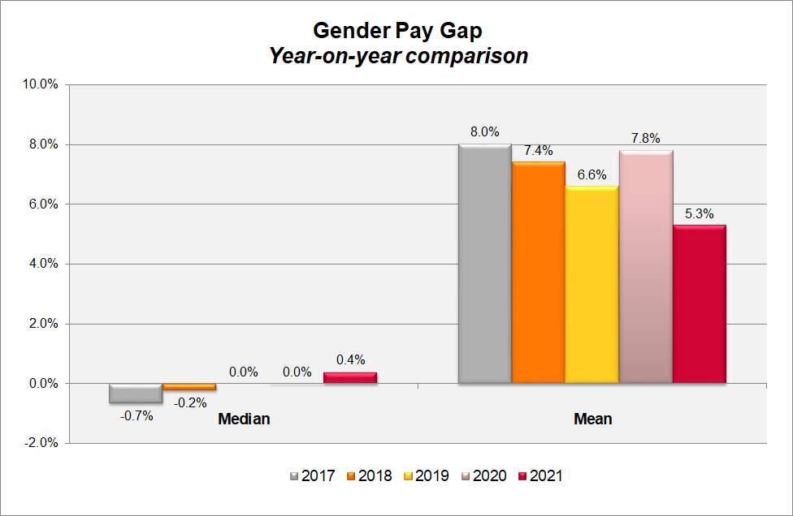

Proportion of male and female employees by quartile group
In line with the social care and charity sectors, Leonard Cheshire employs more women than men, with 79% of our employees being female, and 21% being male.

In the table below, we have divided our workforce into four equal groups ordered from lowest to highest paid. This shows that our female staff are distributed across each of these groups in a way that generally reflects the ratio of female and female staff across the whole organisation.

The proportion of male and female employees in Leonard Cheshire in each of the quartiles is as follows:
Quartile groups | Female | Male
Lower | 78% | 22%
Lower middle | 79% | 21%
Upper middle | 79% | 21%
Upper | 76% | 24%
All | 78% | 22%

The chart below shows the same quartile gender splits:
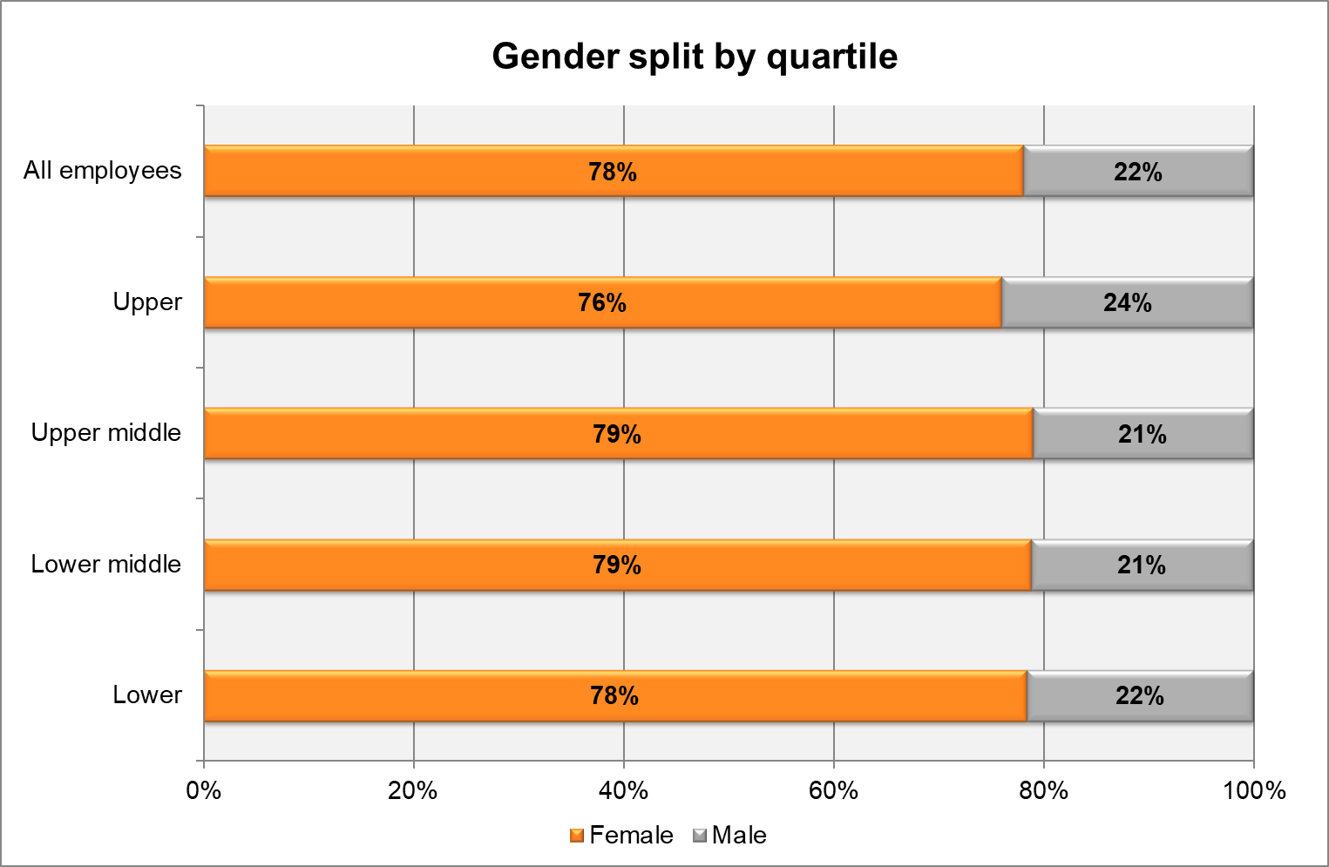

Findings from our gender pay gap analysis
Around 87% of our employees are hourly workers in our UK care operations so the median pay rate is strongly influenced by the size of this group.

Because the pay framework of these hourly paid employees is standardised by role, taking account of small regional variations for market factors, this has resulted in very consistent pay levels between male and female staff for this group, contributing to the generally neutral median gender pay gap for the organisation.

An integrated pay framework covers all salaried staff, based on the scale and level of complexity of the respective roles, so on an equivalent (“like for like”) basis, there is pay equity across these roles too.

Women are relatively more strongly represented in lower level roles, which include both hourly paid social care roles, and more junior salaried roles. This brings down the average earnings for female employees relative to their male colleagues. While women are equally represented at the senior levels of the organisation, this does not offset the impact
of significantly higher proportions of women in relatively smaller roles. This contributes to the negative mean pay gap of 5.3% in favour of male employees. This figure has shown a positive shift since the previous report.

Responses to the gender pay gap analysis
Leonard Cheshire continues working to address our gender pay gap by:
- Continuing to ensure our reward frameworks enhance cross-organisational consistency and internal equity of pay.
- Continuing to encourage the culture of flexible working practices, to minimise career obstacles for working parents – responsibilities typically biased towards women.
- Building awareness of the structural gender bias in the social care and the charity sector and working consciously to counteract this.
- Working collaboratively with our Employee Networks and the Staff Association, to increase awareness, and further build our organisation as an inclusive workplace.
- Ongoing review of our recruitment process to ensure fairness in our process and parity in the offers being made to new starters.
- Ongoing review of our recruitment practices to seek to attract more women into typically male-dominated roles.
- Investing in technical and leadership development, to assist in career progression.
- Review of our talent management and career development processes, with due consideration of career progression of women in the organisation.

While the structural aspects of the gendered nature of the social care and charity sector will continue to challenge us in narrowing our gender pay gap, we are committed to working towards this goal, while we continue to build our organisation as an inclusive, fair and empowering workplace.

Lynn Barbour
Head of Reward and Employee Engagement
Leonard Cheshire

March 2022

All comparator figures are from Office of National Statistics (ONS) - Annual Survey of Hours and Earnings (ASHE) gender pay gap tables.

